**23-11-2021 CD SPOT – 11 2019103573**

**1. To Validate nested for, nested while using lex and yacc.**

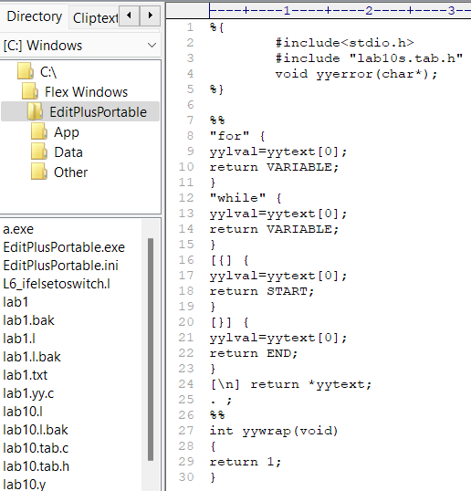 **Lex Code**

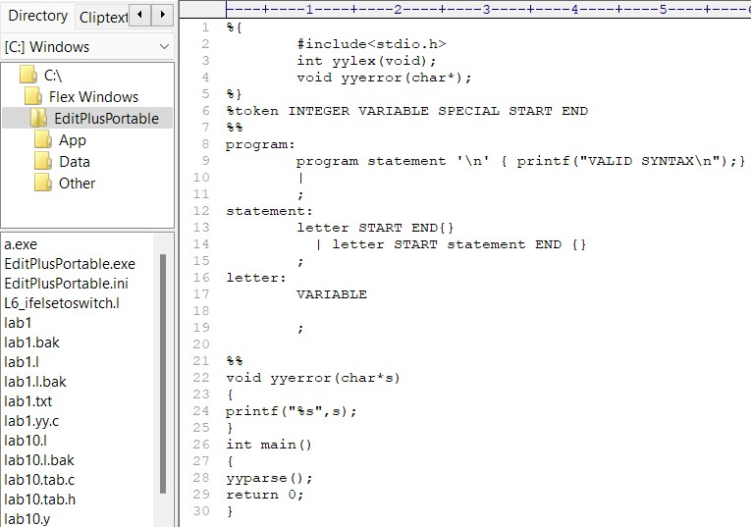**Yacc Code**

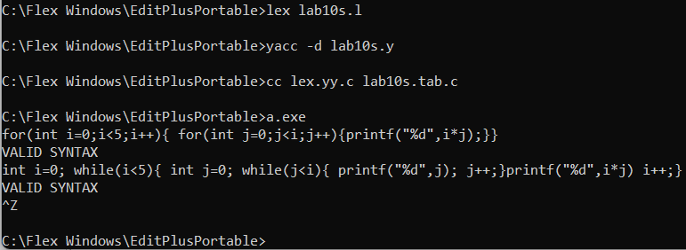**Output**